

**Harvard Chinese Life Science**

**Annual Symposium**

**April 30-May 1, 2016**

Folkman Auditorium, Enders Building, Children’s Hospital Boston

320 Longwood Ave, Boston, MA 02115

Harvard Medical School

Chinese Scholars & Scientists Association

**Organizing Committee Advisors**

**Dr. Xi He, Professor,** Boston Children’s Hospital, Harvard Medical School

**Dr. Xiaole Shirley Liu,** Dana-Farber Cancer Institute, Harvard School of Public Health

**Dr. Yi Zhang,** Boston Children’s Hospital, Harvard Medical School

**Dr. Jiping Wang,** Brigham and Women’s Hospital, Harvard Medical School

**Dr. William Pu,** Boston Children’s Hospital, Harvard Medical School

**Dr. Jean Zhao,** Dana-Farber Cancer Institute, Harvard Medical School

**Dr. Frank Hu,** Harvard School of Public Health

**Dr. Jianzhu Chen,** Massachusetts Institute of Technology

**Organizing Committee**

**Harvard Medical School - Chinese Scientists and Scholars Association**

**(HMS-CSSA)**

Shaokun Shu, Wenqing Cai, Wen Chen, Zhiqiang Lin, Qing Li, Wei Li, Min Tan, Xingxing Kong, Ji Li, Chunxiao Yu, Tengfei Xiao, Yu Qian, Bin Li, Song Yang, Jiaren Liu, Hao Huang, Xiaoyang Zhang, Xinwei Yu, Chao Fang, Jiaxu Hong, Yang Zhang, Le Cong, Christine Guo, Yibin Liu, Heng Zhao, Linchang Huang, Zhou Du, Zhirong Qian, ShaBai, Shuxi Qiao, Chao Dai, Jun Li, Yunlu Xue, Qiong Ye, Yue Huang

**April 30: Academic Lectures**

|  |  |
| --- | --- |
| 8:45 am – 9:15am | **Registration and Light refreshment** |
| 9:15 am – 9:30am | **Opening Remarks**  **Dr. Edward Benz**  President, Dana-Farber Cancer Institute  Professor, Harvard Medical School  Member, National Academy of Medicine |
| **Precision Medicine** | |
| 9:30 am – 10:10am | **Genome alterations and targeted therapies for cancer**  **Dr. Matthew Meyerson**  Professor, Dana-Farber Cancer Institute & Harvard Medical School  Institute Member, Broad Institute of Harvard & MIT  Director, Center for Cancer Genome Discovery at Dana-Farber Cancer Institute |
| 10:10am – 10:50am | **RNA methylation in gene expression regulation**  **Dr. Chuan He**  Investigator, Howard Hughes Medical Institute  John T. Wilson Distinguished Service Professor, University of Chicago |
| 10:50am – 11:30am | **Bacteriolytic Cancer Therapy - From Bench to Bedside**  **Dr. Shibin Zhou**  Associate Professor of Oncology; Director, Experimental Therapeutics  Ludwig Center for Cancer Genetics and Therapeutics  Johns Hopkins University School of Medicine |
| 11:30am – 12:10pm | **From Precision Medicine to Precision Public Health**  **Dr. Frank Hu**  Professor, Harvard School of Public Health and Harvard Medical School  Member, National Academy of Medicine  Director, Boston Nutrition Obesity Research Center Epidemiology/Genetics Core  Co-director, the Program in Obesity Epidemiology and Prevention at Harvard |
| 12:10pm – 1:15pm | **Lunch will be provided** |
| **Cancer Immunotherapy** | |
| 1:15pm – 1:55pm | **PD-1 cancer immunotherapy**  **Dr. Gordon Freeman**  Professor, Dana-Farber Cancer Institute, Harvard Medical School |
| 1:55pm – 2:35pm | **Modeling Human Tumor and Immune System in Mice for Studying Cancer Immunotherapy**  **Dr. Jianzhu Chen**  Ivan R. Cottrell Professor, Koch Institute for Integrative Cancer Research and Department of Biology at MIT |
| 2:35pm – 3:15pm | **Inference of tumor immunity and T-cell receptor repertoire from TCGA RNA-seq data**  **Dr. Shirley Liu**  Professor, Harvard T.H. Chan School of Public Health  Director, Center of Functional Cancer Epigenetics at Dana-Farber Cancer Institute |
| 3:15pm - 3:30pm | **Tea Break** |
| **Innovations in Biology and Translational Research** | |
| 3:30pm – 4:10pm | **Regulation of intracellular proteostasis by protein deubiquitination.**  **Dr. Junying Yuan**  Elizabeth D. Hay Professor of Cell Biology at Harvard Medical School  Member, the American Academy of Arts and Sciences |
| 4:10pm – 4:50pm | **Mechanistic Basis of Metabolic Evolution in Plants**  **Dr.** **Jing-Ke Weng**  Member, Whitehead Institute for Biomedical Research  Thomas D. and Virginia W. Cabot Assistant Professor of Biology, MIT |
| 4:50pm – 5:30pm | **Growth and Size Biology: From Research to Translations**  **Dr. Tian Xu**  Investigator, Howard Hughes Medical Institute  Professor, Vice Chair, Department of Genetics, Yale University School of Medicine |
| 5:30pm – 5:50pm | **2016 Harvard Chinese Life Science Distinguished Research**  **Award Ceremony** |
| 6:30pm – 8:30pm | **Reception (Invited only)** |

**May 1: Entrepreneurship Lectures and Roadshows**

|  |  |
| --- | --- |
| **Entrepreneurship Lectures** | |
| 9:30 am – 10:00am | **TBD**  **Dr. Chiang J. Li**  Founder, President, and Chief Medical Officer, Boston Biomedical, Inc. |
| 10:00am – 10:30am | **Propogating innovation from a platform biotech company**  **Dr. Ting Xu**  Founder and CEO of AlphaMab and Dingfu Biotarget |
| 10:30am – 11:00am | **Case study in biotech & medtech investing**  **Dr. Wei Li**  Founding partner of WuXi Healthcare Ventures |
| 11:00am – 11:30am | **Strategies of building a technology-based start-up**  **Yuwen Liu**  Founding Partner of Bohe Angel Fund |
| 11:30am – 12:30pm | **Panel discussion**  **(Yuwen Liu, Wei Li, Ting Xu, Chaoshe Guo, Hong Zhou)** |
| 12:30pm – 2:00pm | **Lunch will be provided** |
| 2:00pm – 5:00pm | **Entrepreneurship Roadshows (invited only)** |

**Invited Speakers:**

**Academic Lectures:**

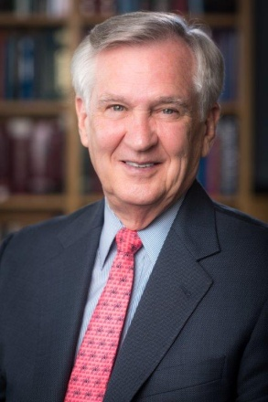**Edward J. Benz Jr., MD,** is President and Chief Executive Officer of Dana-Farber Cancer Institute, Chief Executive Officer of Dana-Farber/Partners Cancer Care, Principal Investigator and Director of the Dana-Farber/Harvard Cancer Center, Director of the Dana Farber/Brigham and Women’s Cancer Center, and a member of the Governing Board of the Dana-Farber/Boston Children's Cancer and Blood Disorders Center. He is also the Richard and Susan Smith Professor of Medicine, Professor of Pediatrics, Professor of Genetics and Faculty Dean Emeritus for Oncology at Harvard Medical School.

An internationally-recognized hematologist, Dr. Benz has authored more than 300 peer-reviewed articles, reviews, chapters, and abstracts. His accomplishments have been recognized by a number of distinctions, including membership in the National Academy of Medicine (formerly the Institute of Medicine), the Association of American Physicians, and the American Academy of Arts and Science.

Dr. Benz is a graduate of Princeton University and Harvard Medical School. He received his training in internal medicine and hematology at Brigham and Women's Hospital, the Children’s Hospital of Boston, the National Institutes of Health, and the Yale University School of Medicine.

**Matthew Meyerson, MD, PhD**, 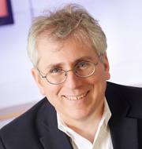is a professor of Dana-Farber Cancer Institute and Harvard Medical School, an Institute Member of Broad Institute of Harvard & MIT and the director of Center for Cancer Genome Discovery at Dana-Farber Cancer Institute. He is committed to discovering genomic alterations in lung cancer, the world's most lethal malignancy, and to translating these discoveries towards therapy through cellular and biochemical studies. Using a combination of computational and experimental genomics approaches they have uncovered novel alterations in genes within receptor tyrosine kinase-regulated pathways e.g. *EGFR*, *ERBB2*, *FGFR2*, *FGFR3*, *BRAF*, *ARAF*, *MAP2K1* & *RIT1*; and in genes regulating RNA splicing (*U2AF1*, *RBM10*) and chromatin remodeling (*SMARCA4*, *ARID1A*). In 2004, the Meyerson laboratory, in collaboration with Dana-Farber colleagues, reported activating mutations in EGFR that conferred sensitivity to the EGFR-targeting inhibitor, gefitinib. This study was the first to reveal a mechanism underlying the efficacy of molecularly targeted therapy and established a rationale for screening patients' tumors for clinically actionable genetic alterations, a service offered today to every cancer patient receiving care at Dana-Farber.

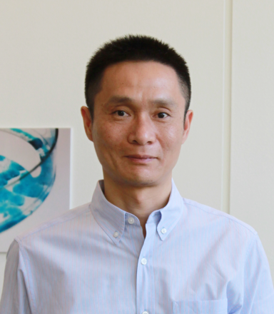**Chuan He, PhD** is the John T. Wilson Distinguished Service Professor in the Department of Chemistry and Director of the Institute for Biophysical Dynamics at the University of Chicago. He was born in P. R. China in 1972 and received his B.S. (1994) from the University of Science and Technology of China. He received his Ph. D. degree from Massachusetts Institute of Technology in chemistry in 2000 with Professor Stephen J. Lippard. After being trained as a Damon-Runyon postdoctoral fellow with Professor Gregory L. Verdine at Harvard University from 2000-2002, he joined the University of Chicago as an assistant professor, and was promoted to associate professor in 2008 and full professor in 2010. He was selected as an as an Investigator of the Howard Hughes Medical Institute in 2013. He is also a member of the Cancer Research Center at the University of Chicago. His research spans a broad range of epigenetics, chemical biology, biochemistry, molecular biology, cell biology, and genomics. His recent research concerns reversible RNA and DNA methylation in biological regulation. His laboratory discovered reversible RNA methylation as a fundamental new mechanism of gene expression at the post-transcriptional level in 2011.

**Shibin Zhou MD, PhD,** has a broad background in cancer genetics and cancer biology, with extensive experience in the development of novel therapeutic approaches. One example is the preclinical and translational development of a therapeutic bacterial strain named C. novyi-NT. The hypoxic tumor compartment poses challenges for both chemo and radiation therapies as hypoxia diminishes the therapeutic effects of chemotherapeutic agents and radiation. Conversely, this tumor compartment, hypoxic and immune-privileged, provides a unique niche for anaerobic bacteria to colonize and grow. C. novyi-NT is an attenuated strain of the anaerobic bacterium Clostridium novyi. When injected intravenously, C. novyi-NT spores are not toxic to healthy animals but can selectively germinate within and colonize tumors, resulting in massive necrosis and tumor regression. In addition to direct tumor destruction by bacterial growth, we have shown that the C. novyi-NT infection elicits a potent host antitumor immune response leading to long-term cures, which can be augmented when combined with immune checkpoint blockade. This line of investigation has also led to the observation that the efficacy of immune checkpoint blockade can be substantially enhanced by anti-epigenetic therapy. Myeloid Derived Suppressor Cells (MDSCs) were later identified as the target of the epigenetic inhibitors. Based on these promising preclinical studies, two Phase I trials are being conducted, one with C. novyi-NT and the other with entinostat plus pembrolizumab. Dr. Shibin Zhou has been playing a leading role in both preclinical studies and translation of these works into clinical trials.

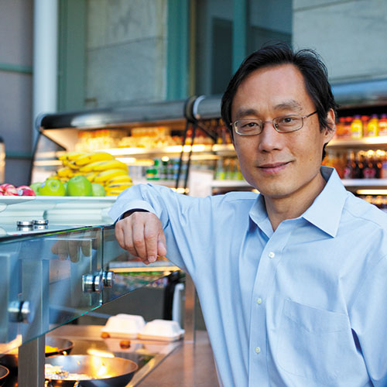**Frank Hu, MD, PhD** is Professor of Nutrition and Epidemiology at Harvard T.H. Chan School of Public Health and Professor of Medicine, Harvard Medical School and Brigham and Women’s Hospital.  He serves as Co-director of the Program in Obesity Epidemiology and Prevention at Harvard and Director of Boston Nutrition and Obesity Research Center (BNORC) Epidemiology and Genetics Core. Dr. Hu received his MD from Tongji Medical College in China and a PhD in Epidemiology from University of Illinois at Chicago. His research is mainly focused on nutritional and lifestyle epidemiology and prevention of obesity, diabetes, cardiovascular disease as well as gene-environment interactions. He has published >800 original papers and reviews (H-index 188) and a textbook on Obesity Epidemiology (Oxford University Press 2008). Dr. Hu is the recipient of the Kelly West Award for Outstanding Achievement in Epidemiology by American Diabetes Association in 2010. He has served on the Institute of Medicine (IOM) Committee on Preventing the Global Epidemic of Cardiovascular Disease, the AHA/ACC Obesity Guideline Expert Panel, and the 2015 Dietary Guidelines Advisory Committee, USDA/HHS. He currently serves on the editorial board of *Lancet Diabetes & Endocrinology*, *Diabetes Care*, and *Clinical Chemistry*. Dr. Hu was elected to the U.S. National Academy of Medicine in 2015.

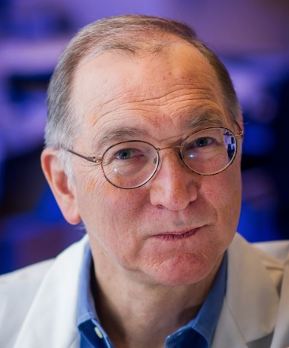**Gordon J. Freeman, PhD** works in the Department of Medical Oncology at Dana-Farber Cancer Institute and is Professor of Medicine at Harvard Medical School. Dr. Freeman earned his BA in Biochemistry and Molecular Biology, and PhD in Microbiology and Molecular Genetics from Harvard University. His research has identified the major pathways that control the immune response by inhibiting T cell activation (PD-1/PD-L1 and B7-2/CTLA-4) or stimulating T cell activation (B7-2/CD28).

In 2000, Dr. Freeman discovered PD-L1 and PD-L2, and showed they were ligands for PD-1, thus defining the PD-1 pathway and the drug target: block the interaction. He showed the function of PD-1 was to inhibit immune responses and that blockade enhanced immune responses. He showed that PD-L1 is highly expressed on many solid tumors such as breast and lung, as well as some hematologic malignancies and allows these tumors to inhibit immune attack. He received the 2014 William B. Coley Award for Distinguished Research in Tumor Immunology for this work that led to development of PD-1 pathway blockade for cancer immunotherapy.

**Jianzhu Chen, PhD** is the Ivan R. Cottrell Professor of Immunology and Professor of Biology at Koch Institute for Integrative Cancer Research and Department of Biology at MIT. He is also the lead Principle Investigator of the Infectious Disease Interdisciplinary Research Group of Singapore-MIT Alliance for Research and Technology (SMART). Dr. Chen’s research seeks fundamental understanding of the immune system as well as its application in disease intervention. Recently, his research activity has focused on developing humanized mouse technology for modeling human diseases with autologous immune system and therapeutic development.

Dr. Chen received a B.S. degree from Wuhan University in China and a Ph.D. degree from Stanford University. He was a postdoctoral fellow and then an instructor at Harvard Medical School before he joined the faculty in the Department of Biology at MIT.

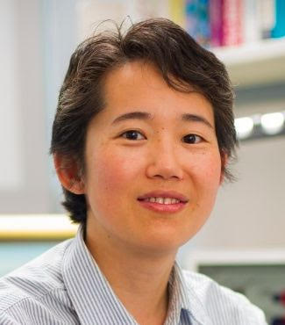**Dr. X. Shirley Liu, PhD** received PhD in Biomedical Informatics and PhD minor in Computer Science from Stanford University in 2002. She is now Professor of Biostatistics and Computational Biology at Harvard T.H. Chan School of Public Health and the Director of the Center of Functional Cancer Epigenetics at Dana-Farber Cancer Institute. Her research focuses on algorithm development and integrative modelling of high throughput genomic data to understand the specificity and function of gene expression regulators in tumour development, progression, drug response and resistance. In computational biology, her laboratory developed widely used algorithms for transcription factor motif finding, ChIP-chip/seq, DNase-seq, and CRISPR screen data analysis. In epigenetics, she and colleagues identified the chromatin signature of embryonic pluripotency, and were the pioneers to use the dynamics of nucleosomes, histone marks, and DNase hypersensitivity to predict driving transcription factors and cis-elements in a biological process. In cancer biology, she and colleagues identified novel functions of ESR1, AR, FOXA1, EZH2, and NOTCH1 in various cancers, discovered many cancer-related long non-coding RNAs, and reported novel associations of tumour immunity with patient clinical features and outcome. Dr. Liu has an H-index of 66 according to Google Scholar statistics and has published over papers in 40 in Nature, Science or Cell series journals. She received the Sloan Research Fellowship in 2008, was named a Yangtze River Scholar and 1000 Talent Scholar in China in 2012 and 2013, and was selected to receive the Richard E. Weitzman Outstanding Early Career Investigator Award from the Endocrinoe Society in 2016.

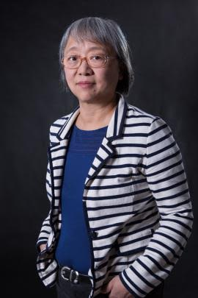**Junying Yuan, PhD** is a Professor of Department of Cell Biology at Harvard Medical School. She received her Ph.D. in Neuroscience from Harvard University in 1989 and her undergraduate degree from Fudan University, Shanghai, China, in 1982. Dr. Yuan carried out her Ph.D thesis work at the Massachusetts Institute of Technology. She was first appointed as Assistant Professor at Harvard Medical School in 1992, when she became a Principal Investigator of the Cardiovascular Research Center at Massachusetts General Hospital. She joined the Department of Cell Biology in 1996 and was appointed a Professor of Cell Biology at Harvard Medical School in 2000. Junying Yuan made critical contributions to our understanding of apoptosis and necroptosis, two fundamental mechanisms that regulate the survival and death of mammalian cells. Her lab provided the first insight into the molecular mechanism that regulates apoptosis in mammalian cells. Also her lab discovered necroptosis, a regulated necrotic cell death mechanism, and the role of RIPK1 kinase as a key mediator of necroptosis. This discovery overturned the traditional dogma that necrosis can only be a form of unregulated passive cell death and demonstrated the possibility of inhibiting necrotic cell death in multiple forms of degenerative and inflammatory human diseases. A small molecule inhibitor of RIPK1 kinase (Nec-1) discovered by Yuan lab is currently in preparation for a human clinical trial targeting neurodegenerative disease.

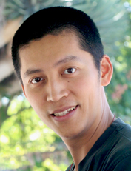**Jing-Ke Weng, PhD** received his B.S. (2003) in Biotechnology from Zhejiang University, Hangzhou, China. He received his Ph.D. (2009) in Biochemistry from Purdue University, and was a pioneer postdoctoral fellow at the Salk Institute for Biological Studies and Howard Hughs Medical Institute between 2009 and 2013. Currently he is a member of the Whitehead Institute for Biomedical Research, and a Thomas D. and Virginia W. Cabot Assistant Professor of Biology at Massachusetts Institute of Technology. Dr. Weng's research focuses on understanding the origin and evolution of plant specialized metabolism at enzyme, pathway, and systems levels, as well as how plants exploit discrete small molecules to interact with their surrounding biotic and abiotic environments. In addition, he utilizes plant as a unique model system to study human diseases, including metabolic syndromes and protein-misfolding diseases. He is also interested in elucidating the molecular mechanisms underlying the "matrix effect" known from many traditional herbal remedies used for thousands of years. Dr. Weng is a member of the American Society of Plant Biologists, and has won numerous awards in his career, including Alfred P. Sloan Research Fellow (2016), Searle Scholar (2015), Pew Scholar in the Biomedical Sciences (2014), American Society of Plant Biologists Early Career Award (2014), and Tansley Medal for Excellence in Plant Science (2013).

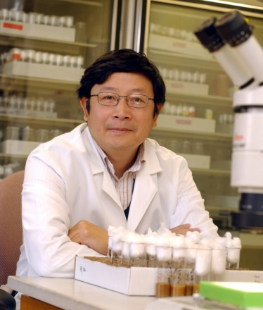**Tian Xu, PhD** has developed several genetic tools used to analyze and manipulate individual cells and to conduct genetic screens in fruit flies and mice. The mosaic analysis system that he and Gerald Rubin established has been widely used and broadly applied in the research community in the past two decades and is continuously being modified to address specific questions including visualization and manipulation of individual neurons. Utilizing these tools, he has pioneered the genetic dissection of growth control and identified the key regulators and pathways that are evolutionarily conserved for controlling growth. These include the identification of the founding member of the Hippo/Lats pathway, the establishment of the PTEN/TSC/mTor pathway and the first elucidation of its role in growth regulation, and the demonstration of the involvement of TNF/JNK pathway in non-autonomous growth control in tissue homeostasis and oncogenic cooperation. These studies have not only advanced our understanding of growth control during normal development, but have also contributed to our realization of growth control as a fundamental feature of cancer biology in addition to the regulation of cell cycle and cell death. His work has also highlighted the importance of cell-cell communication in tissue size and growth control and in oncogenic cooperation. Finally, the PTEN/TSC/mTor pathway is activated in approximately 70% of human cancers and a number of syndromes. The elucidation of the pathway and the epistasis suppression data provided the initial realization that mTor inhibitors, *e.g.,* rapamycin and rapalogs, could be used as therapeutic agents for TSC/LAM syndromes and cancers. The Xu lab has recently turn its attention to obesity and has identified the molecule that induces gastric emptying, providing a novel approach to combat obesity by regulating digestion. Xu loves teaching and his genetics course is one of the most popular classes at Yale.

**Entrepreneurship Lectures:**

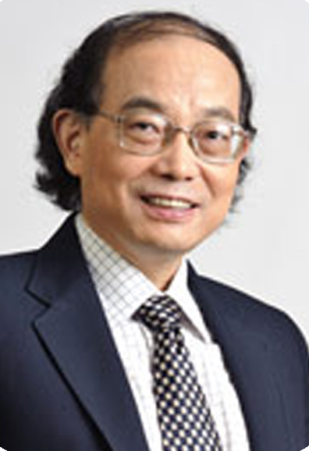**Xin-Yuan Fu, PhD.** Professor and Senior Principle Investigator Department of Biochemistry, and Cancer Science Institute Yong Loo Lin School of Medicine, National University of Singapore Chief Scientist, CheerLand Institute of Precision Medicine

Xin-Yuan Fu received his PhD in molecular biology at Columbia University in 1988 (Mentor: James Manley); postdoctoral training in Rockefeller University with James Darnell (1988-1991). Dr Fu was an Assistant Professor in Mt Sinai School of Medicine NY (1992-1994); an Associate Professor at Yale University (1994-2003), a Full Professor at Indiana University (2004-2015). Prof. Fu was the founding director of Tsinghua Institute of Genome Research of Tsinghua University, China (2000-2006) and the Head of Department of Biochemistry of National University of Singapore (2008-2011). Dr Fu and his colleagues discovered the STAT gene family and the JAK-STAT signaling Pathway. He has made a number of seminal discoveries in molecular mechanisms of mammalian development, immunity and diseases in the past 30 years. Particularly, in the past 23 years since Dr Fu's original discovery, there are over 30,000 publications on the JAK-STAT pathway, and over three FDA approved drugs against the JAKSTAT. In the past 7 years, Fu laboratory has focused on STAT's role in regulation of inflammation, development and cancer.hiangFounder, President, CEO, and Chief Medical Officer, Boston Biomedical, IncExecutive Officer, Head of Global Oncology for Sumitomo Dainippon Pharma Group

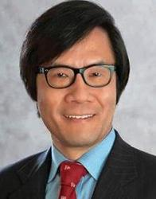**Chiang J. Li, MD** is a physician, scientist, inventor, entrepreneur, and seasoned corporate executive with internationally recognized accomplishments in therapeutic science and medical innovation. Dr. Li has founded multiple successful biotech startups that have collectively created hundreds of R&D jobs as well as several billions of dollars in valuation. He founded Boston Biomedical in 2006 with a team of 2 dozen researchers laid off from a prior employer, and has served as its President and CEO since its inception. Under his leadership, Boston Biomedical has grown to become an organization with more than 120 oncology product R&D researchers, a seasoned business management infrastructure, and a world-leading product pipeline designed to target cancer cell stemness and other promising avenues of oncology research. In 2013, Boston Biomedical was selected as the sole recipient of the special award “Company to Watch” by the 10th Massachusetts Economic Impact Award Committee.

Dr. Li has performed biomedical research for more than 20 years and has more than 50 publications in leading biomedical journals, including numerous highly cited articles. He is a named inventor in more than 230 patents or patent applications worldwide, including a number of first-in-class cancer therapeutics, an award-winning platform technology for designing gene-targeted therapeutics, and one of the world’s first synthetic biology therapeutics.

Dr. Li has more than 15 years of patient care and clinical development experience in academia and industry, and has led efforts to translate a number of his inventions from bench to bedside for patients with life-threatening disorders. He has been a chief executive in charge of product R&D in public and private biotech companies for more than a decade, including drug discovery, preclinical development, clinical development, pharmaceutical development and manufacture, regulatory affairs, and intellectual property.

Dr. Li and his work have received a number of awards/recognitions with more recent examples including his election as Fellow of the US National Academy of Inventors, direct election as Fellow of the American College of Physicians (invited direct election is considered a singular honor), North American Technology Innovation of the Year (2010, Frost & Sullivan), GRL Award in biotechnology (Korea), Distinguished Foreign Professor (Dongguk University, Korea), Honoree for outstanding achievement (Massachusetts Asian American Commission), Life Time Achievement Award (CAST-USA), and Massachusetts Immigrant Entrepreneur Award (sole recipient for Science Business, 2013). He is also a member of the Overseas Experts Advisory Committee (China State Council, Office of Foreign Affairs), and serves on the Board of Trustees at Beth Israel Deaconess Medical Center of Harvard Medical School.

Dr. Li graduated from the Harvard-MIT Division of Health Science and Technology, received his MD magna cum laude from Harvard University, and completed residency and fellowships at Brigham and Women’s Hospital/Dana-Farber Cancer Institute, Beth Israel Deaconess Medical Center. He has also received executive education at Harvard Business School.

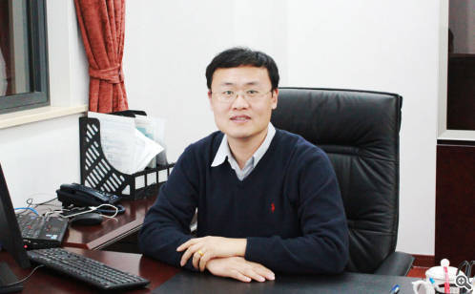**Ting Xu**, **PhD** founder and CEO of AlphaMab and Dingfu Biotarget in Suzhou, P.R.China. Dr. Xu founded AlphaMab early 2009 and successfully transoform the company an innovative biotherapeutic oriented R&D powerhouse. In 2011, Dingfu Biotarget was set up to focus on development of biologics in tumor immunotherpy.  
AlphaMab has so far transferred dozens bisimilars to major pharmaceutical companies in China and other countries. Meanwhile, Alphamab devoted most of its resource into innovative protein/antibody engineering platform and novel biologics. Currently, The company now has in pipeline over 30 mAbs and engineered proteins, mostly innovative, 4 IND filed with CFDA. In operation merely 3 years ago, Dingfu Bio has more than 7 active program ongoing with its first IND planned 2nd half of 2016. Prior to AlphaMAb, Dr. Xu had had worked in several USA biotechnology companies developing engineered proteins and also downstream process. Dr. Xu is the recipient of prominent “One thousand talent” rewards and holds adjunct professor positions with Jilin University and Shanghai Institute of Materia Medica. Dr. Xu holds BSc in Biochemistry from Nanjing University,and Ph.D. from Chinese Academy of Science

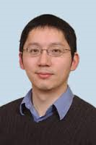

**Wei Li, PhD** Prior to joining WuXi Healthcare Ventures as a founding partner, Dr. Li focused his effort on healthcare and life science venture investment opportunities at Fidelity Biosciences, Fidelity Growth Partner Asia, and Baird Venture Partners. He also led drug discovery projects and technology licensing due diligence at Vertex Pharmaceuticals, a biotech company in Boston, MA. During his scientific career, Wei first-authored numerous scientific publications in journals including Science, Proceedings of the National Academy of Sciences, and the Journal of Biological Chemistry.

Wei received a B.S., with distinction, in Chemical Physics from University of Science and Technology of China, a Ph.D. in Biochemistry and Mammalian Genetics from Harvard University, and an MBA from the Kellogg School of Management at Northwestern University, where he was elected Beta Gamma Sigma, with a concentration in Finance, Accounting and Marketing.

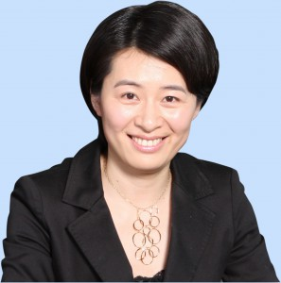**Yuwen Liu,** Founding Partner of Bohe Angel Fund, a 200M RMB fund jointly invested by Wuxi Apptec, Hengrui, Simcere, TigerMed and BGI, etc. Before she set up this angel fund, she was Executive Director of Suzhou Industrial Park Biotech Development Co. Ltd. (BioBAY) and chairwoman & CEO for 9 years. When she was also Investment Committee Member for BioVENTURE and Board Director of Innovent, Admera, Chiral Quest, GenePharma, Reproposing and BrightGene, and Chairwoman of Qiagen (Suzhou) Translational Medicine and Suzhou BioTOP Biotech. She joined the company as EVP in 2005, was instrumental in building BioBAY to be one of the fastest growing biotech clusters serving ~400 biotech startup companies. She started her career as QA Engineer for Capsugel in 1997, then moved up to QC manager, QA/QC manager and BD manager until joined Perrigo as first China Chief Representative in 2003. Yuwen graduated from China Pharmaceutical University with master degree in Pharmaceutics and Master of Management at Fudan University and Norwegian Management School BI, and is a licensed pharmacist.

**Other gusest:**

**Hong Zhou:** CL Investment group, Chief investment officer

**Chaoshe Guo**: Vice President and Senior R&D Director, Beijing Biocytogen Co., Ltd

**Wen Chen**: Deputy GM & VP of business development Hangzhou Tigermed Consulting Co., Ltd

**Moses Zhao**: Managing Director, Yonghua Capital, Yongjin Group

**2016 Harvard Chinese Life Science YongJin Annual Distinguished Research Award Awardees:**

**(Sponsored by YongJin Group)**

|  |  |  |
| --- | --- | --- |
| **Name** | **Title** | **Affiliation** |
| **Jiazhi Hu** | Postdoctoral Fellow | Boston Children's Hospital, Harvard Medical School |
| **Bo Duan** | Postdoctoral Fellow | Dana-Farber Cancer Institute, Harvard Medical School |
| **Junli Liu** | Postdoctoral Fellow | Boston Children's Hospital, Harvard Medical School |
| **Yubao Wang** | Scientist | Dana-Farber Cancer Institute, Harvard Medical School |
| **Chungyiu Tang** | Graduate Student | Harvard University |
| **Haojian Zhang** | Postdoctoral Fellow | Dana-Farber Cancer Institute, Harvard Medical School |
| **Heng Ru** | Postdoctoral Fellow | Boston Children's Hospital, Harvard Medical School |
| **Peng Du** | Postdoctoral Fellow | Boston Children's Hospital, Harvard Medical School |
| **Xiaoyang Zhang** | Postdoctoral Fellow | Dana-Farber Cancer Institute, Harvard Medical School |
| **Ju Tian** | Graduate Student | Harvard University |

**Sponsors:**



